Title of your submission: Calibri Bold 22 points, single line space. The style is called “Title”
Keywords
List your keywords here, separate by commas. The name of the style for the keywords is “Keyword List”

Headings go in Calibri Bold 16 points, 1.5 lines for line spacing
The name of the style for the heading is “Heading 1.” All the paragraphs must be set in Calibri (Body) regular 12 points and 1.5 lines for line spacing. Leave one empty line to separate paragraphs. Align left all the headings, sub-headings, keywords, and paragraph text. This template has a US letter page size: 8.5” x 11” and 1.1” for the top, left, and right margins, and 1.2” for the bottom margin.

Sub-headings go in Calibri Bold 14 points bold, 1.5 lines for line spacing
The name of the style for the sub-heading is “Heading 2.” We encourage to use only headings (Heading 1) and sub-headings (Heading 2).

3rd level subheadings go in Calibri 13 (body) italic, 1.5 lines for line spacing
The name of the style of a sub-sub-heading is “Heading 3.” Use this level of hierarchy only if you really need it.

Citations
Use “The Chicago Manual of Style” for your citations and references. You can find more information about this style at:
- http://www.chicagomanualofstyle.org/tools_citationguide.html
- https://owl.english.purdue.edu/owl/resource/717/01/
- https://docs.google.com/viewerng/viewer?url=https://owl.english.purdue.edu/media/pdf/20110928111055_949.pdf

The Chicago style does not apply to the rest of the document’s formatting. This template has “Chicago” as chose citation/reference style. You can change this option in the tab “References.” As you can notice from the previous list, leave the default blue color for URLs. No need to color them black. We encourage you to use the default style for lists. Separate the end of a list and the beginning of a new paragraph with an empty line space.

Tables
The font size for paragraph is 12 points. You can use the same font size or lower for text in your tables. Select the font size that appears more convenient for your content. Use bold text for the headings. We encourage you to avoid adding unnecessary lines, and use ½ to 1.5 point 25% black lines. Leave one empty line between the end of the paragraph and the beginning of your table. Align your table to the center if necessary. We also encourage you to apply 0.08” to all the “cell margins” of your tables. Position the caption below the figure or table. See example below.

Heading 1 | Heading 2 | Heading 3 | Heading 4
Aspect 1 | Content 1 | Content 2 | Content 3
Aspect 2 | Content 1 | Content 2 | Content 3
Aspec3t | Content 1 | Content 2 | Content 3
Table 1. This caption is an example.
Include a caption for your tables and figures. Use the style named “Caption” in both cases. Word applies this style when you use the option “Caption” from the “Insert” menu.

Images
We encourage you to include one image at least: a photograph, illustration, sketch, or diagram that makes the comprehension of the text easier. Try to position an image close to the text that mentions it. If necessary, use a fixed-position “Text Box” to insert a figure and its caption. Especially, when the figure does not fit in the page and leaves a big blank break between pages. We encourage you to play with the proportions of your images to avoid this situation or place your images in text boxes. Align your images to the center.

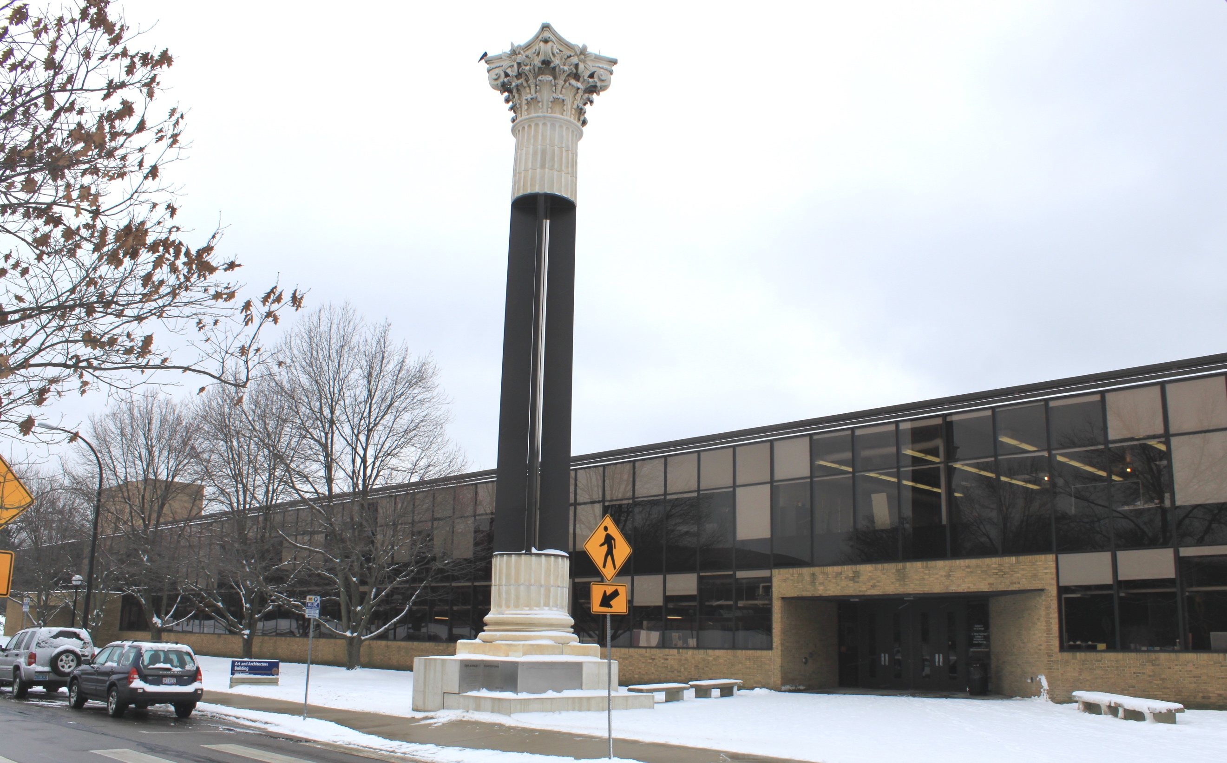
Figure 1. Art and Architecture building. University of Michigan, Ann Arbor. Photo by Dwight Burdette.
Use images with a 300 dpi of resolution. If your image has a resolution of 150 dpi or 72 dpi, its dimensions (width and height) should be large enough to obtain a good screen and print quality. Moreover, verify that the information of your images can work in black and white, not only in color. Use the label “Figure” to refer to photographs, sketches, diagrams, illustrations, and other visuals in your content, except tables.

References (example that uses the “Bibliography” style)
Auger, James. 2013. “Speculative Design: Crafting the Speculation.” Digital Creativity 24 (1): 11–35. https://doi.org/10.1080/14626268.2013.767276.
Bardzell, Jeffrey, Shaowen Bardzell, Peter Dalsgaard, Shad Gross, and Kim Halskov. 2016. “Documenting the Research Through Design Process.” In Proceedings of the 2016 ACM Conference on Designing Interactive Systems, 96–107. New York, NY, USA: ACM. https://doi.org/10.1145/2901790.2901859.
Buchanan, Richard. 2001. “Design Research and the New Learning.” Design Issues 17 (4): 3–23.
Nelson, Harold G., and Erik Stolterman. 2012. The Design Way: Intentional Change in an Unpredictable World. Second edition. Cambridge, Massachusestts ; London, England: The MIT Press.
Zimmerman, John, Jodi Forlizzi, and Shelley Evenson. 2007. “Research Through Design As a Method for Interaction Design Research in HCI.” In Proceedings of the SIGCHI Conference on Human Factors in Computing Systems, 493–502. New York, NY, USA: ACM. https://doi.org/10.1145/1240624.1240704.

